Data structure lab

Megha Patel

20124107

BTECH CSE

**1)C program to print all vowels and consonants characters separately.**

#include<stdio.h>

int

main ()

{

char s1[50];

int i;

printf ("enter a string\n");

scanf ("%s", s1);

printf ("vowels in string = ");

for (i = 0; s1[i] != '\0'; i++)

{

if (s1[i] == 'a' || s1[i] == 'e' || s1[i] == 'i' || s1[i] == 'o'

|| s1[i] == 'u' || s1[i] == 'A' || s1[i] == 'E' || s1[i] == 'I'

|| s1[i] == 'O' || s1[i] == 'U')

{

printf (" %c ", s1[i]);

}

}

printf ("\nconsonants in string=");

for (i = 0; s1[i] != '\0'; i++)

{

if (!

(s1[i] == 'a' || s1[i] == 'e' || s1[i] == 'i' || s1[i] == 'o'

|| s1[i] == 'u' || s1[i] == 'A' || s1[i] == 'E' || s1[i] == 'I'

|| s1[i] == 'O' || s1[i] == 'U'))

{

printf (" %c ", s1[i]);

}

}

}

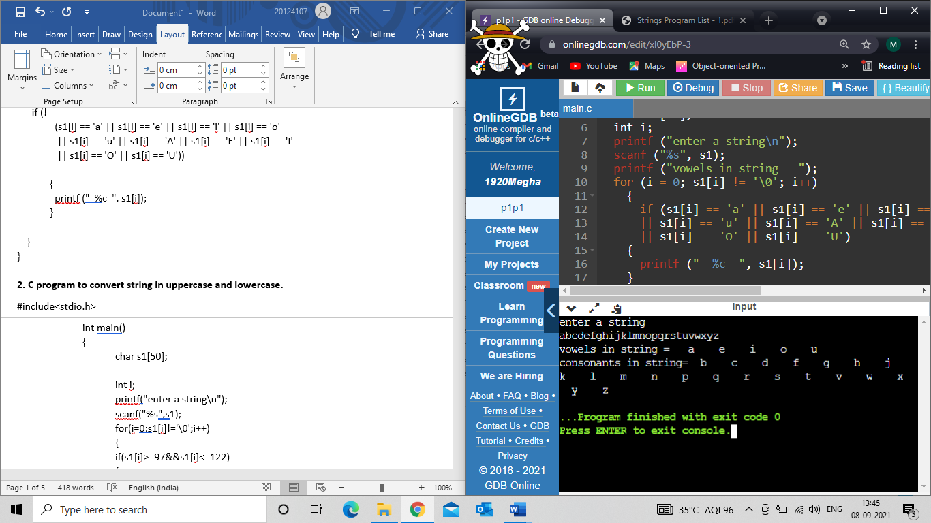

**2. C program to convert string in uppercase and lowercase.**

#include<stdio.h>

int main()

{

char s1[50];

int i;

printf("enter a string\n");

scanf("%s",s1);

for(i=0;s1[i]!='\0';i++)

{

if(s1[i]>=97&&s1[i]<=122)

{

s1[i]-=32;

printf("%c",s1[i]);

}}}

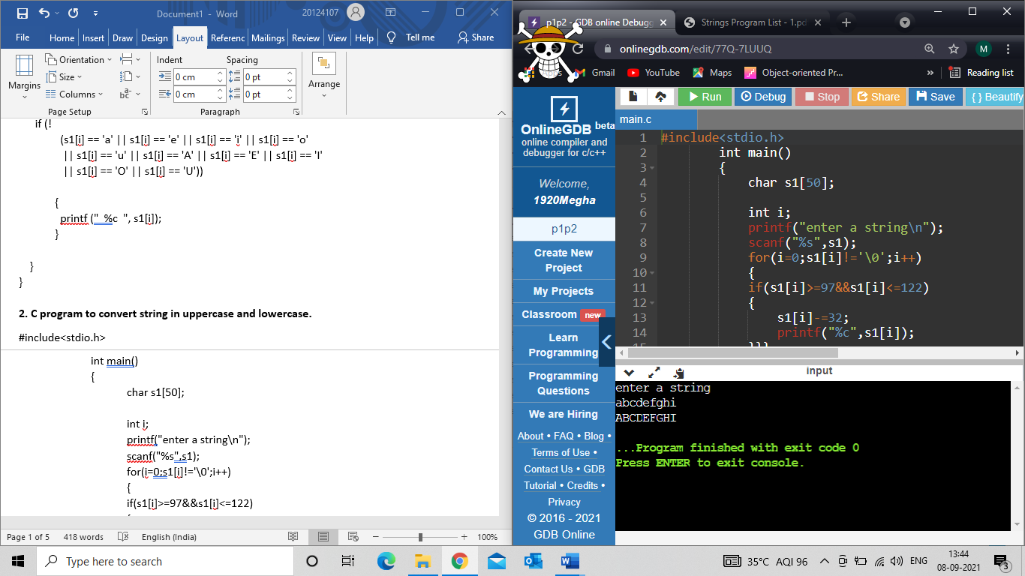

**3. C Program to reverse string in the same variable, without using another string variable to reverse.**

#include <stdio.h>

#include<string.h>

int main ()

{

char str[20], c;

int i, len, j;

printf ("enter string");

scanf ("%s", str);

len = strlen (str);

for (j = len; j >= 0; j--)

{

printf ("%c", str[j]);

}

}

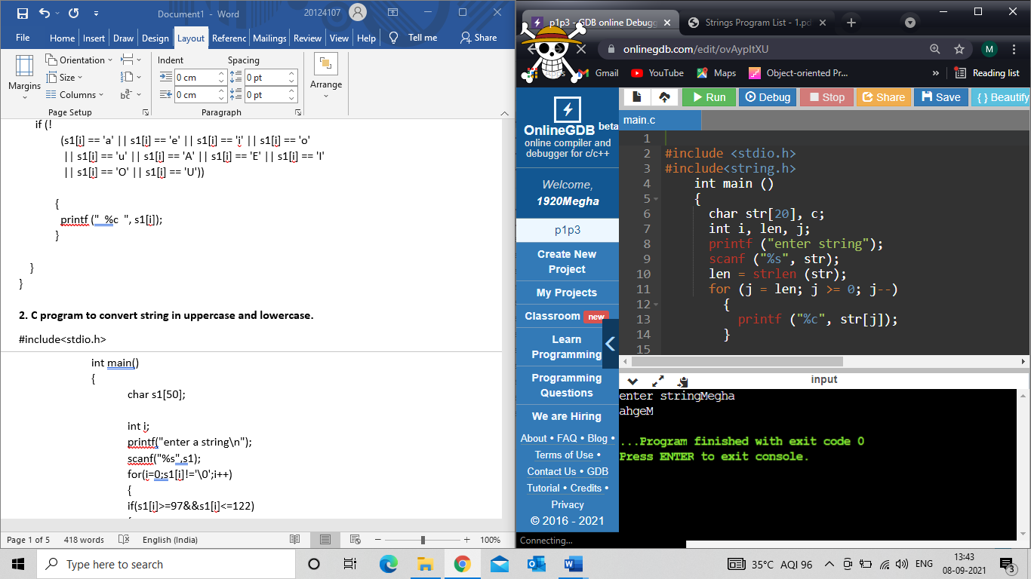

**4. C Program to find occurrence of a character in the string.**

#include <stdio.h>

int main()

{

char str[20];

char c;

int i=0,j=0;

printf("enter string\n");

scanf("%s",str);

printf("enter character to know is occurance\n");

scanf(" %c",&c);

for(i=0;str[i]!='\0';i++)

{

if(str[i]==c)

{

j++;

}

}

printf("%c is occuring %d times",c,j);

}

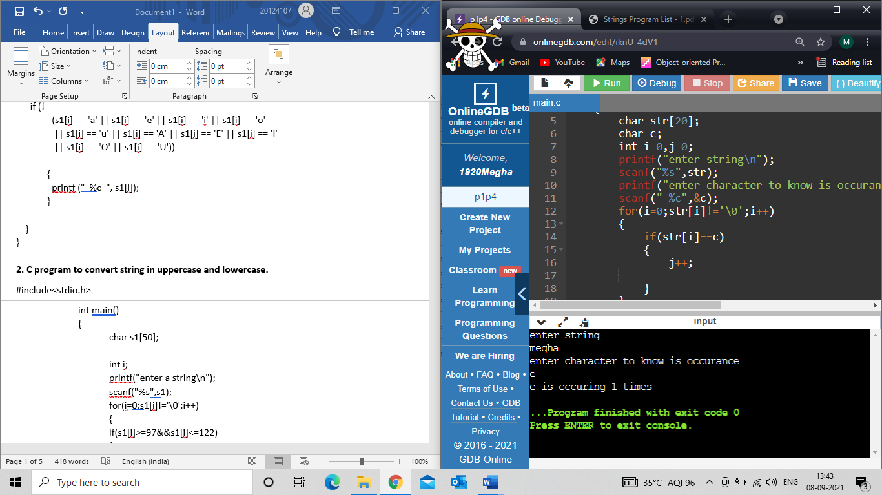

**5. Write a program to concatenate two strings without using strcat( ).**

#include<stdio.h>

void main()

{

char s1[50],s2[50];

int i=0,j=0;

printf("\n\n\nenter first string\t");

gets(s1);

printf("enter second string\t");

gets(s2);

while(s1[i]!='\0')

i++;

while(s2[j]!='\0')

{

s1[i]=s2[j];

j++;

i++;

}

s1[i]='\0';

printf("%s",s1);

}

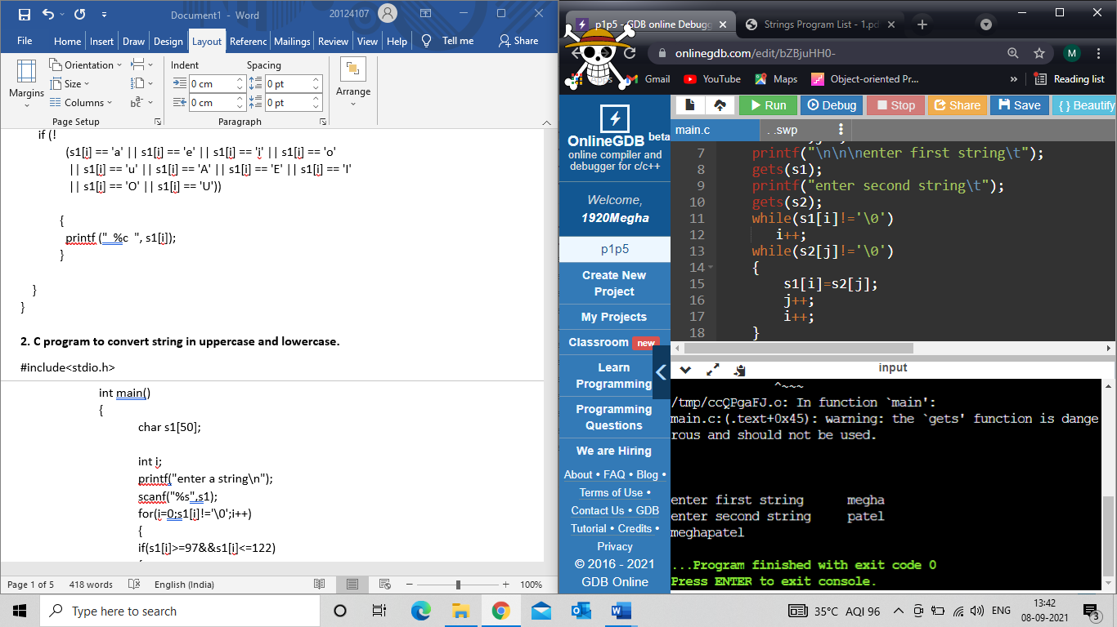

**6. Write a C program to count the no. of vowels, consonants and digits & whitespaces.**

#include<stdio.h>

int main()

{

int c=0,v=0,s=0,n=0;

char s1[50];

char s2[50];

int i;

printf("enter a string");

gets(s1);

for(i=0;s1[i]!='\0';i++)

{

if(s1[i]=='a'||s1[i]=='e'||s1[i]=='i'||s1[i]=='o'||s1[i]=='u'||s1[i]=='A'||s1[i]=='E'||s1[i]=='I'||s1[i]=='O'||s1[i]=='U')

{

v++;

}

elseif(s1[i]=='0'||s1[i]=='1'||s1[i]=='2'||s1[i]=='3'||s1[i]=='4'||s1[i]=='5'||s1[i]=='6'||s1[i]=='7'||s1[i]=='8'||s1[i]=='9')

{

n++;

}

else if(s1[i]==' ')

{

s++;

}

else

{

c++;

}}

printf("vowels= %d \n",v);

printf("spaces = %d\n",s);

printf(“numbers=%d\n”,n);

printf("consonants=%d \n",c);

}

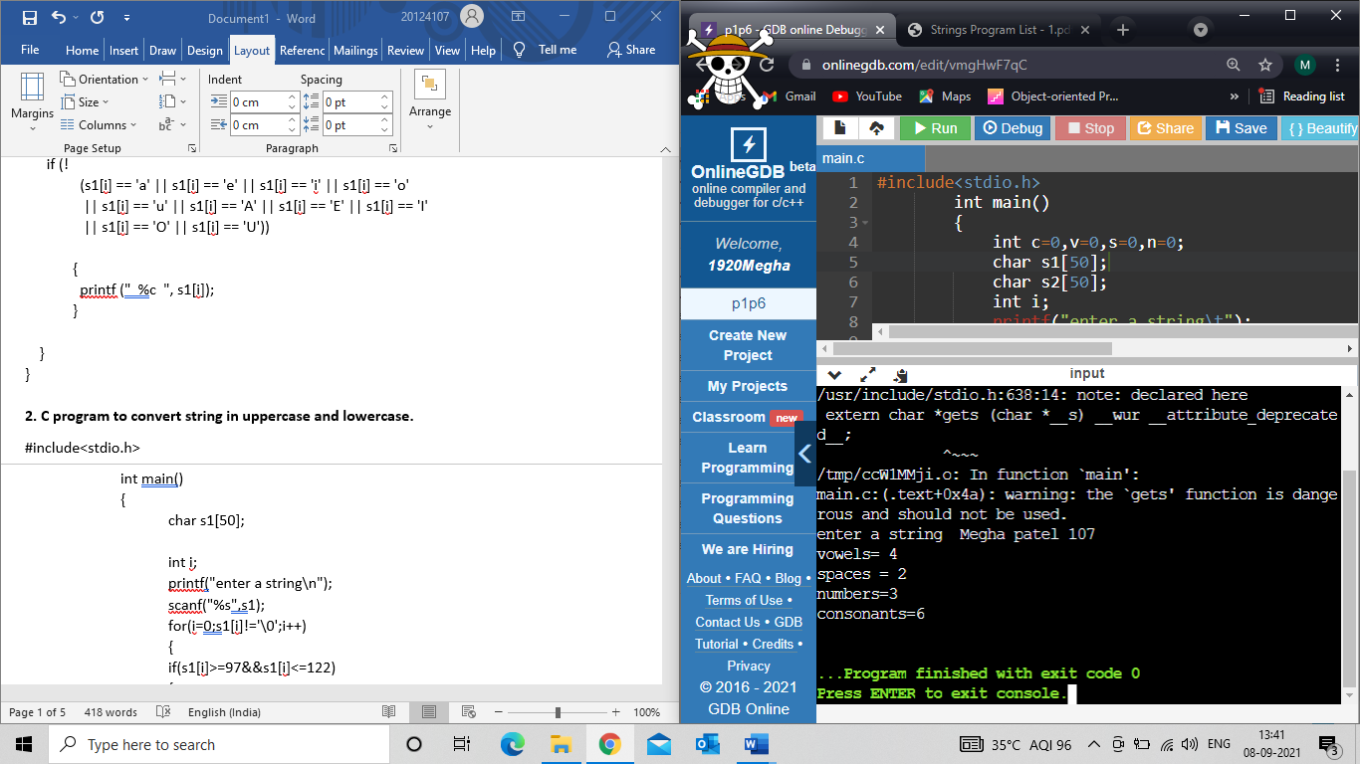

**7. Reverse a string using recursion.**

void rev(char *s)

{

if(*s)

{

rev(s+1);

printf("%c",*s);

}

}

int main()

{

char str1[50];

printf("string to reverse?");

scanf("%[^\n]",&str1);

rev(str1);

}

